Code of Conduct for Moffat Rugby Club Volunteers/Coaches, Parents/Carers and Children/Youth Players

Parents/Carers
The conduct of parents/carers is important in promoting a positive experience for both their own child and for other children and young people participating in rugby. This is about positive and supportive encouragement in general. Good spectator behaviour is one element of this. Poor behaviour by adults on the side-lines can distract some children and young people and in the worst case may risk a child or young person dropping out of rugby or other sports. Moffat Rugby Club has this Code of Conduct for volunteers/coaches, parents/carers and children/youth players which promotes positive behaviour and clarifies the consequences of breaching it.

Code of Conduct for adults working/volunteering with children and young people
A Code of Conduct has several important functions:
- It sets out what behaviour is acceptable and unacceptable and provides transparency for all on what practice and behaviours to expect from others.
- It defines standards of practice expected from those to who it applies.
- It forms the basis for challenging and improving poor practice and behaviour.

Moffat Rugby Club supports and requires all members to observe the following standards of practice, including verbal and non-verbal actions when working/volunteering with children and young people.

All concerns about breach of this Code of Conduct will be taken seriously and responded to in line with Moffat Rugby Club’s appropriate policy.

Good practice
- Make rugby fun, enjoyable and promote fair play.
- Treat all children and young people equally, with respect, dignity and fairness. Challenge where you see other adults or children and young people participating in disrespectful or bullying behaviour.
- Involve parents/carers wherever possible.
- Build balanced relationships based on mutual trust.
- Include children and young people in decision-making processes.
- Always work in an open environment, wherever possible. Avoid private or unobserved situations.
- Put the wellbeing of each child or young person first before winning or achieving performance goals.
- Be an excellent role model including not smoking, drinking alcohol, taking drugs or swearing in the company of children and young people.
- Recognise the developmental needs and capacity of children and young people.
- Avoid excessive training and competition, pushing children and young people against their will and putting undue pressure on them.
- Follow Moffat Rugby Club and the SRU’s Digital Communication and Social Media guidance in relation to communicating with children and young people.

Practice to be avoided
In the context of your role within Moffat Rugby Club, the following should be avoided:
- Having ‘favourites’ – this could lead to misinterpretation, or resentment and jealousy by other children and young people.
- Spending excessive amounts of time alone with children and young people away from others.
- Where possible, doing things of a personal nature for children or young people that they can do for themselves.
- Contacting children and young people online outside Moffat Rugby Club’s / the SRU’s Digital Communication and Social Media guidance.

Unacceptable practice
In the context of your role within Moffat Rugby Club, the following practices are unacceptable:
- Allowing allegations made by a child or young person, or about the wellbeing or protection of a child or young person, to go unrecorded and unreported.
- Forming intimate emotional, physical or sexual relationships with children or young people.
- Making sexually suggestive comments to a child or young person, allowing or engaging in touching a child or young person in a sexually suggestive manner, or engaging in sexually provocative games.
- Being physically violent towards a child or young person.
- Allowing children or young people to swear or use sexualised language unchallenged.
- Behaving in a coercive or controlling manner towards a child or young person.
- Allowing a child or young person to share a room alone with a coach or adult member or inviting a child or young person into your home.

Code of Conduct for parents and carers
- Remember that children and young people play rugby for enjoyment, as well as competition.
- Remember that your behaviour may affect not only your child but the other children and young people participating.
- Stay outside the field of play and in the Spectator’s Area (where provided).
- Never engage in, or tolerate, offensive, insulting or abusive language or behaviour.
- Always respect the match officials' decisions.
- Let the coaches do their job and not confuse the players by telling them what to do.
- Encourage the players to respect the opposition and match officials.
- Never criticise a player for making a mistake. Remember that mistakes are an important part of learning and wellbeing.
- Help your child get their kit ready, help them learn to wear appropriate kit/safety gear correctly.
- Help your child to fuel their energy levels, with a balanced diet.
- Make sure your child brings a water bottle for use during training/games.
- Help your child get enough rest before and after training/games.
- Help your child play and practise in a positive frame of mind; this can include things like encouraging them to clean their own boots and gumshield after games/training.
- Applaud and praise effort, discipline, sportsmanship and skills during and after training/games.
- Remember that the game is about more than the result, it’s part of a learning process.
- Please support coach decisions as they are responsible for how the team and players develop. They will make decisions as part of a coaching/game plan, which you may not be aware of, please do ask questions.
- Engage with the coach/coaches to identify things you can encourage your child to work on while away from training/games.
I understand that breaches of the code may result in action being taken by Moffat Rugby Club.
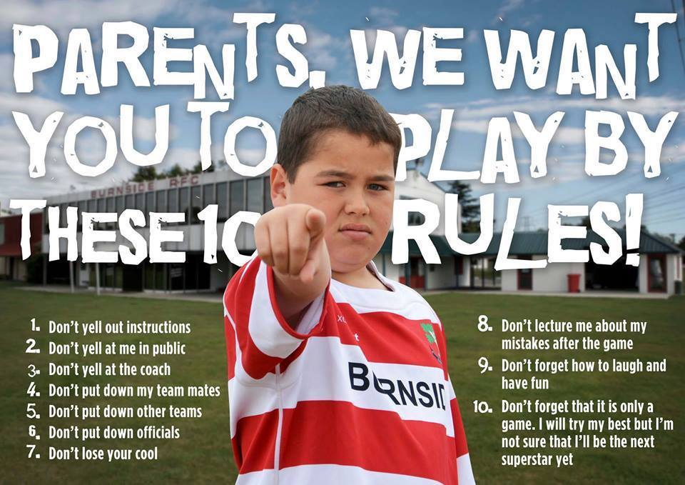
If you have any concerns about the wellbeing of a child or young person, you can contact: a volunteer at Moffat Rugby Club or Vicky Alston, Child Protection Officer, Moffat Rugby Club, or Child Wellbeing and Protection in Sport on 0141 419 1156 or Children 1st Parentline on 08000 28 22 33.

Code of Conduct for children and young people

Adults at Moffat Rugby Club should help to make rugby safe and fun. This is your job too. This means respecting other players and the people who are there to help you to learn. You should do this by:

- Being ready and on time for training and games.
- Respecting the coach and other helpers.
- Accepting what the coach or match officials ask you to do in the rules of the game.
- Playing to the best of your ability with a positive attitude.
- Never swearing at or insulting anyone, including other players.
- Telling your parents or carers where you are, or if you are going to be late.
- Following advice from sport doctors or physios to keep you safe and injury free.
- Never bullying other players either yourself or in a group.

Bullying can happen between children or between adults and children. It means things like:

- name calling
- making fun at someone’s expense
- giving only negative feedback
- hitting
- shoving
- stealing
- damaging belongings
- spreading rumours
- making threats
- sending/posting nasty messages
- leaving people out on purpose.

If you are worried about something, don’t keep it to yourself. Speak to an adult who you know and trust such as a parent, coach, teacher, the Child Protection Officer at Moffat Rugby Club, a guidance teacher, doctor or school nurse.

If there isn’t anyone you can talk to, you can contact Childline in Scotland on 0800 1111 or at childline.org.uk. It’s free, private and confidential.

